CMPD 244

Programming II

Lab 1: Basic I/O in C++

*In this lesson, you are supposed to learn on how to write your program in C++. This includes display the output, header file related, declare the variable, and get input from user.*

*If you have experienced in other programming languages, C++ language is more or less the same but some of the syntax may differ from the others.*

*You need to solve the problems given by using C++ language.*

**Program Sample 1:** Basic C++ codes without using standard classes

#include <iostream>

int main()

{

int num1; //declare variable

std::cout << "Enter any number:\n"; //display output

std::cin >> num1; //get input from user

std::cout << "The number that you have entered is " << num1

<<std::endl; //display output with a variable value and end the

line(\n)

return 0;

}

**Program Sample 2:** Basic C++ codes with using standard classes

#include <iostream>

using std::cout;

using std::cin;

using std::endl;

int main()

{

int num1; //declare variable

cout << "Enter any number:\n"; //display output

cin >> num1; //get input from user

cout << "The number that you have entered is " << num1 << endl;

//display output with a variable value and end the line (\n)

return 0;

}

**Program Sample 3:** Basic C++ codes with using namespace standard classes

#include <iostream>

using namespace std;

int main()

{

int num1; //declare variable

cout << "Enter any value:\n"; //display output

cin >> num1; //get input from user

cout << "The number that you have entered is " << num1 << endl;

//display output with a variable value and end the line (\n)

return 0;

}

**Exercises:**

**Question 1**

|  |
| --- |
| You are required to write a C++ program to print the following text;  Hello there!  How are you?  Welcome back to the C++ programming lab.  All the best in your study. |

This program should not receive any input from the user.

**Question 2**

Write a program to get the user’s information; full name, age, address. The program will print out the user’s information.

Sample Output:

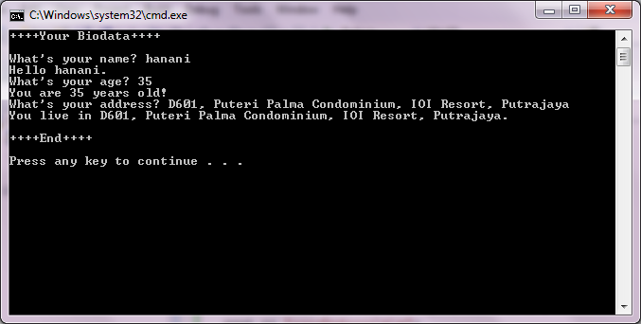

**Question 3**

Create a simple program to perform Addition operation. The program will require TWO (2) integers as the input from user. The program should be able to display the correct result.

Sample Output:

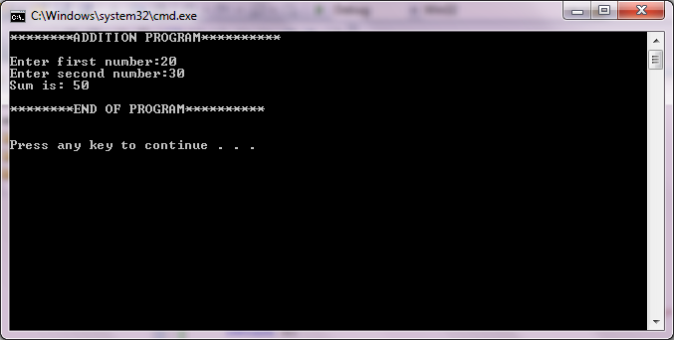

**Question 4**

Write a program that will compute the area of a rectangular. The user is required to enter 2 values; length and width. The formula as follows, area = length * width.

*Don’t forget to submit your source code and the screen capture of your program to our Brighten portal with the subject: CMPD244 Lab1 <YourStudentID><Your Full Name> at the end of this lab session. Good Luck! ☺*

